

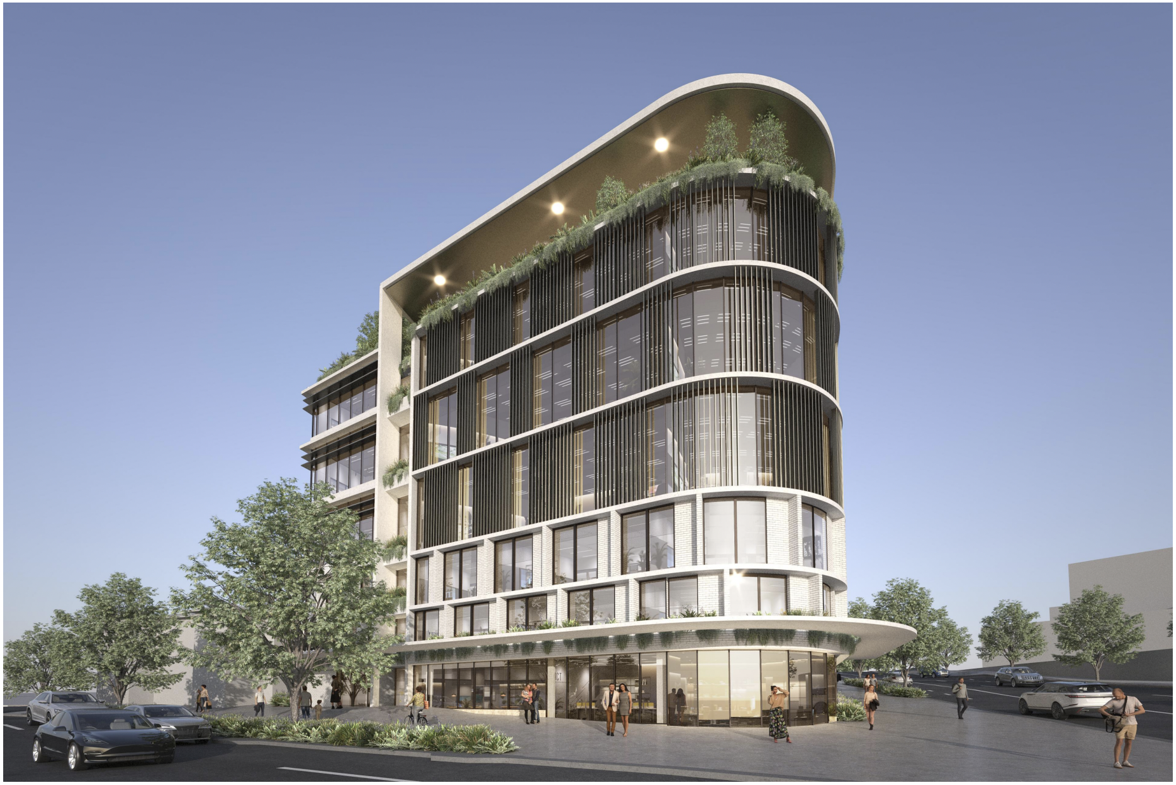

**Development Proposal | Information Memorandum**

**Annerley Health Hub**

97-99 Cornwall Street and 275-281 Ipswich Road, Annerley QLD 4103

Lane Barry, Daniel Ciccotosto-Camp, Daniel Dyer, Rakto Yoshioka, Conor Tsang

Issue Date: 16th May 2024

# Table of Contents

**Executive Summary 3**

**Site Overview 4**

**Market Dynamics 5**

Economic Outlook 5

Healthcare Property Sector Overview 5

A-REIT Market Conditions 6

Healthcare REIT Performance 7

**Asset Overview 7**

Demographic and Location Analysis 7

Local Analysis 8

Building Projection 9

Sustainability 10

**Strategic Positioning | SWOT Analysis 11**

**Development Timeline 11**

**Investment Analysis 13**

Construction Cost Estimation 13

Demolition Cost Estimation 13

Asbestos 14

Lease Agreements and Tenancy Terms 15

Land Value Estimation 15

**Fund Structure** 17

Capital Structure 17

Debt Schedule 18

**Viability of Project** 19

Financial Metrics 19

Risk and Sensitivity Analysis 20

Recommendation 21

**Appendix A: Valuation Model** 22

**Appendix B: SWOT Analysis** 33

**Appendix C: Risk Identification & Mitigation** 35

**Appendix D: Funding Literature Review** 37

Private (Senior) debt 37

Considerations and fees 37

Loan Length 38

Mezzanine Financing 38

Joint ventures 38

**Bibliography** 38

# Executive Summary

Cornerstone Group is seeking to complement the service offering within the Princess Alexandra Hospital precinct with the Annerley Health Hub (**AHH**), comprising a 6-storey, 4-basement building. The proposed redevelopment is distinct in its focus on multi-disciplinary allied healthcare services, supplemented by a small retail component. The 6-storey building will house a range of services, including general practice, pathology, radiology, day surgery, and other specialised offerings.

This information memorandum constructs a comprehensive analysis of the AHH project on behalf of Live Well Healthcare REIT (**ASX: LWH**) to assess the overall efficacy of the project to add to the portfolio of healthcare properties of LWH. To evaluate the viability of the project, crucial information, including risks, both macroeconomic and site-specific, as well as opportunities associated with acquiring, developing, and holding the proposed development have been addressed. Pershica Associates’ real estate division seeks to maximise the potential offering of 97-99 Cornwall Street and 275-281 Ipswich Road, harnessing the site’s unique synergies while also addressing the serviceability challenges faced by local public sector healthcare.

Value Proposition

Despite the economic disruptions caused by the COVID-19 pandemic and recent inflationary pressures, the healthcare property sector in Australia remains robust. The aging population in Queensland, coupled with strong government funding and favourable lease covenants, compounds the reliability of cashflows. With a projected annualised industry revenue growth of 2.7% over the next five years, the healthcare sector's defensive nature guarantees stability and growth potential.

The AHH presents a defensive investment opportunity that offsets exposure to emerging macroeconomic headwinds, leveraging the unique Annerley location alongside the foot traffic from the Princess Alexandria Hospital and capitalising on a shifting local landscape. This configuration attracts premium tenants seeking to capitalise on local demand, ensuring sustained occupancy and favourable lease incentives. The concentration of highly specialised services localised in one centre offers a premium value proposition to lessee’s looking to capitalise on the local demand, helping ensure the long-term viability, occupancy, and lease terms of the development. Given healthcare cashflows' defensiveness and the favourable state outlook, the project's capital structure targets a leverage ratio of approximately 32.92%. This includes a 7% contingency to manage construction phase uncertainties.

Key financial performance indicators include a levered IRR of 14.9%, an annualized ROE of 10.92%, and a cash-on-cash return of 32.3%. The project’s NPV stands at $82.9 million, confirming its potential to generate substantial value for investors. These metrics reflect a well-structured, high-return investment opportunity, poised to capitalize on the growth and stability of the healthcare property market. Overall, the analysis completed by Pershica Associates finds the AHH project profitable with a low risk of producing losses, therefore recommends LWH to invest in the project and implement into their portfolio to benefit from long-term returns.

|  |  |
| --- | --- |
| **Financial Metrics** | * **NPV:** A$82,859,140.58 * **IRR:** 14.91% * **Cash-on-Cash:** 32.30% * **ROE (Annualised):** 10.92% * **ROTDC (Annualised):** 7.33% * **Fire sale (Minimum Price Floor):** A$7,671,306.43 * **Land Value:**  A$5,748,413.14 |

# Site Overview

Annerley Health Hub bolsters a 2456m2 property located on 97-99 Cornwall Street and 275-281 Ipswich Road, Annerley QLD 4103, with a road frontage of Cornwall Street and Ipswich Road. The plans proposed for the development of the property are fully approved by the Ministerial Infrastructure Designation.

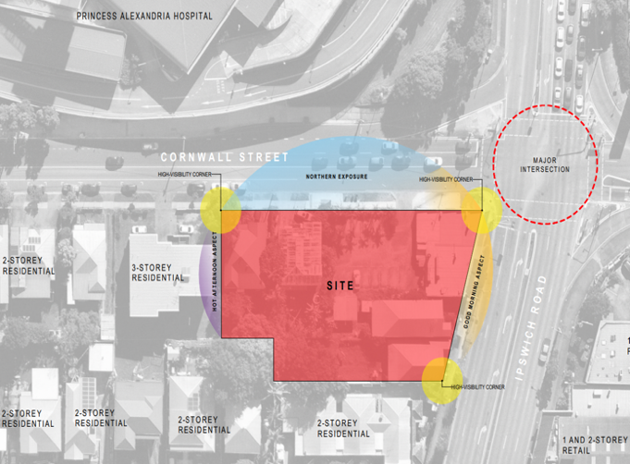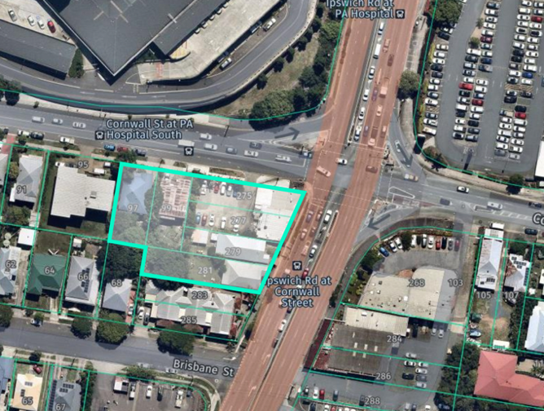

|  |  |
| --- | --- |
| Figure 1 | Aerial photography of subject property |
| Address | 97-99 Cornwall Street and 275-281 Ipswich Road, Annerley QLD 4103 |
| Real Property Description (Lot on Plan) | Lot 72 on RP37992, Lot 73 on RP 37992, Lot 1 on RP37992, Lot 2 on RP37992, Lot 3 on RP37992 and Lot 4 on RP37992 |
| Total Land Area | 2,456m2 |
| Road Frontage | Cornwall Street and Ipswich Road |
| Subject Property | Aims to complement the service offerings within the Princess Alexandra (PA) Hospital precinct comprising:   * 6 storey building Area that will cater for a range of allied health services including general practice, diagnostic imaging, pharmacy, pathology, radiology, and day surgery * Ground level, with retail and an ancillary café along Ipswich Road * Dedicated pedestrian entrance and vehicle access from the Cornwall Street frontage * Carparking areas within a basement level comprising 200 spaces across 4 basement levels |
| Easements | No easements burdening the property |
| Heritage | The property is not built on any historical sites or heritages |

# Market Dynamics

## Economic Outlook

The global economy is still recovering from the COVID-19 pandemic, with severe inflationary shocks distorting commodity pricing. Domestically, inflation proves to be sticky with a slower-than-anticipated retraction back to the target inflation band. Australian real gross domestic product contracted to 0.3 per cent (seasonally adjusted, chain volume measure) in the March quarter from 0.2% in the preceding December quarter (Australian Bureau of Statistics, 2024; KPMG, 2024). As inflation moderates, bond markets price in an expected return to the target range of 2–3 % in 2025 and to reach the midpoint in 2026. While goods price inflation has declined, services price inflation remains high due to continued excess demand and strong domestic cost pressures (*Outlook*, 2024) (Richardson, 2024a). The Reserve Bank Board left the cash rate target unchanged at 4.35% as of May 2024, following an aggressive hiking cycle to curb global commodity inflation. Private business investment grew at 0.7 per cent, with investments in non-dwelling building construction in the private sector having a significant contribution, rising by 5.0% in the December quarter (Australian Bureau of Statistics, 2024). Household spending, including spending on health, has contracted -2.3% in March 2024 following sustained growth in preceding months, suggesting. potential profitability constraints engulfing the average Australian household (Australian Bureau of Statistics, 2024).

Inflationary shocks, divisive political tensions and global monetary policy may have long-run implications in the sustainability of asset pricing assumptions and the pricing of core commodities. Valuation-wise, the healthcare sector's dip in FY23 has paradoxically fostered opportunity, epitomised by the MSCI World Healthcare index’s average P/E trailing the broader market by 5%. This disparity suggests an undervaluation that investors could exploit in the coming years, especially as healthcare's forward earnings growth is projected to outpace other sectors (Blackrock, 2024). Such metrics indicate a potential market correction that could favour projects such as the AHH cemented by munificent government healthcare initiatives.

## Healthcare Property Sector Overview

Australia’s healthcare industry is predicated on this inelastic demand due to its importance in resolving health issues amongst the general population, which nullifies the pursuit of substitute services. Age is a key determinant of demand for healthcare services and a driver of industry growth (Richardson, 2023). As depicted in Figure 2 below, individuals in Australia aged 65 and over are significantly increasing and are estimated to account for 40% of all health services expenditure despite only making up 16.5% of Queensland’s population. As shown in Figure 3, the ageing population will create organic demand, driving industry revenue by an annualised 3.1% over the next five years. Allied healthcare services, which the AHH will primarily support, provide 10.3% ($21.3bn) of healthcare industry revenue (Richardson, 2023).

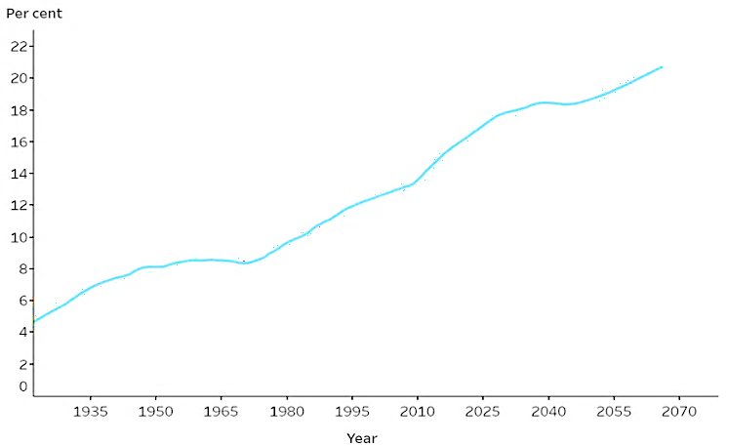

|  |  |  |  |
| --- | --- | --- | --- |
| Figure 2 (left) | Individuals in Australia aged 65 and over | Figure 3 (right) | Domestic Healthcare Expenditure |

Long-term fundamentals, including strong government funding and lease covenants, back Australia’s healthcare property sector. Long Weighted Average Lease Expiry figures are a key driver in investment demand, with prime WALEs in healthcare averaging 15.5 years (M3 Property, 2023). Privately funded healthcare buildings are predicted to generate $2 billion in 2024, while healthcare buildings generate $7.2 billion in 2024 (Kartik Jeswanth, 2023). Investment yields average 4.5%-5% for prime medical assets (M3 Property, 2023). The mounting prevalence of healthcare needs among Australians will drive demand for clinics such as AHH, thus providing opportunities for greater tenancy rates, longer tenancy periods, and incentives to demand higher rent prices, ultimately benefiting LWH.

|  |  |
| --- | --- |
| Figure 4 (left) | Weighted Average Lease Expiry (WALE) of comparable Australian listed REITs (A-REITs). The weighted average lease expiry is provided in orange at 97.40%. |
| Figure 5 (right) | Occupancy rates of comparable A_REITS. The weighted average occupancy rate is provided in orange at 15.56%. |

## A-REIT Market Conditions

A-REITS have faced volatile trading conditions recently due to significant disruptions in macroeconomic indicators, including retail and health, caused by the COVID-19 pandemic. A-REITS have demonstrated an annualised growth of 0.7% over the past five years and in 2023 alone growing by 0.9% (Burnet, 2023). Despite this recent growth, the A-REIT index has underperformed many equity indexes by –1.59% annually for the last five years. Comparatively, the Dow Jones Equity All REIT index experienced a 1.3% total return for Q4, compared to a 10.6% for the S&P500. On an annual basis, the REIT index was outperformed by the S&P 500 by 22%. This underperformance relative to broader indices underscores the sector's sensitivity to contractionary monetary policy and its negative implications for the borrowing and property markets (Hudgins, 2024).

In the year to date, the ASX A-REIT 300 has outperformed the ASX 300; however, this is driven by the performance of the two largest index constituents: Goodman Group (GMG) and Scenter Group (Burke, 2024). Beyond these two REITS headline overperformance, the rest of the sector has underperformed as the potential for sustained higher interest rates has weighed on property market valuations. The medium-term outlook is positive as rates are likely to start decreasing, with the A-REIT sector typically outperforming the ASX 300 in RBA cutting cycles (Burke, 2024). Future A-REIT prospects are highly optimistic, with industry revenue forecasted to grow at an annualised 2.7% in the next 5 years to total A$21.2 billion (Schroeder, 2023) (Richardson, 2024). Medium-term outlooks price optimistically, driven primarily by the RBA's expectations of interest rate cuts.

## Healthcare REIT Performance

Prominent healthcare REIT: HealthCo Healthcare and Wellness (HCW) has traded as low as a 27% discount to its NTA this year and returned at approximately 17% YTD, underperforming the REIT market, which returned just 3% in the year to date (Burke, 2024). HCW’s discounted pricing is due to market concerns and subsequent overselling regarding a restructuring of its key tenant, Healthscope. In the US market, the Diversified Healthcare Trust, a comparative healthcare REIT with a $200 million market cap, returned losses of 34% in 1Q24, marking it the worst-performing REIT for the quarter. Healthcare REITS in the US had a total return of –0.9% in Q1 2024, with top-performing healthcare REITS returning up to 14% in the same quarter, reflecting the US REIT market breadth and variability (Hudgins, 2024).

Healthcare’s defensive property sub-sector translates to less downside risk to HCW’s book valuation than the A-REIT sector, implying that the discount is bloated due to Healthscope's restructure. HCW has strong financial and legal positions that underpin confidence in future earnings (Burke, 2024). Dexus Healthcare Property Fund (DHPF) made a $51 million acquisition of the Southport Private Hospital, whilst RAM Essential Services Property Fund (REP) acquired Eden Private Hospital for $28.3 million. These acquisitions underline the value potential of medical assets currently in the market. The $3.8 billion Australian Unity fund, an unlisted healthcare property trust, delivered an 8.8% return in the last year, further displaying the current opportunities in the healthcare property sector (Filmer, 2024).

The re-indexation of Medicare rebates for health services compounds revenue growth in this sector. A 3.6% indexation factor applied on July 1, 2023, has begun to ease funding issues in the healthcare sector (Richardson, 2023). The present cost-of-living crisis is causing many people to self-insure and even delay or not use healthcare services. In 2022-2023, 7% of Australians delayed or did not see a general practitioner for cost reasons (Richardson, 2023).

# Asset Overview

## Demographic and Location Analysis

The AHH site, strategically positioned near the PA Hospital and a soon-to-be redeveloped shopping mall, indicates growth potential for the Annerley area. With substantial frontage on Cornwall St (70m) and Ipswich Rd (30m) and adequate separation from the intersection per TAPS policy, the site is conveniently located 520 meters from major public transport interchanges. Despite a proposed parking lot of 200 spaces falling short of BCC TAPS policy requirements, its alignment with average parking rates for similar healthcare facilities in Brisbane and proximity to public transport makes it viable. Noise concerns are addressed with plans for a solid balustrade to the outdoor terrace and gardens on level 05 and acoustic treatments to the vehicle and carpark access on level 01, facilitating approval for extended weekday operating hours. Environmental assessments reveal that the site is not listed in the Environmental Management or Contaminated Land Registers, indicating minimal environmental constraints.

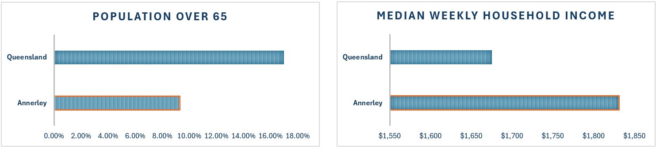

|  |  |
| --- | --- |
| Figure 6 (left) | The percentage of population aged over 65 years. Source: (Australian Bureau of Statistics, 2021) |
| Figure 7 (right) | Median weekly income in Queensland versus the suburb of development project. Source: (Australian Bureau of Statistics, 2021). Source: (Australian Bureau of Statistics, 2021) |

These demographics indicate the potential for increased private health service utilization. Market analysis suggests that despite Annerley's younger population (Figure 6), its higher-income households are likely to drive demand for services offered by the proposed AHH (Figure 7).

## Local Analysis

There are various health clinics and health hubs in the surrounding area for the development. The nearest major hospital (excluding the PA) is Greenslopes Private Hospital, representing a market share competitor to the AHH. Given the widespread and inelastic demand for healthcare services, however, key indicators for demand will be the ability of the PA to keep pace with its demand and the income of households surrounding it, which will be a key driver as to whether they use private health which drives demand for allied health clinics (Richardson, 2023). AHH provides many of the same services as the hospital, so it can be inferred from PA performance numbers whether there will be demand. The patients examined within the clinically recommended time are the key metric in examining whether the PA keeps up with demand requirements. The table will reference the below categories.

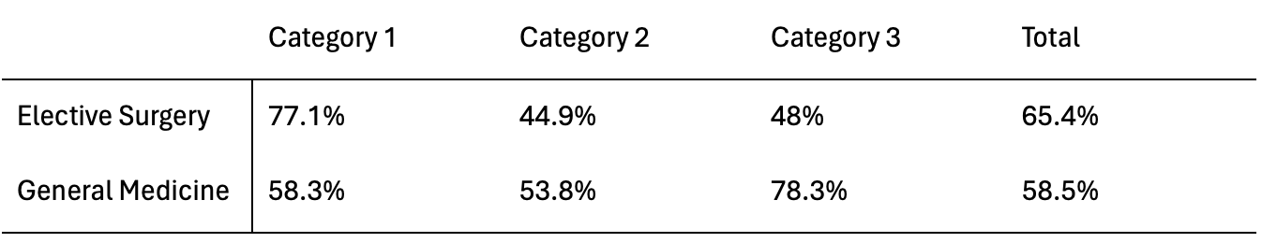

Category 1: Elective Surgery/appointment required within 30 calendar days  
Category 2: Elective Surgery/appointment required within 90 days  
Category 3: Elective surgery/appointment required within 365 days

|  |  |
| --- | --- |
| Table 1 | Patients seen within the clinically recommended time at the PA Hospital (full performance table in appendix) |

Table 1 above suggests the PA hospital is struggling to meet local demand to fulfil patient demands within the clinically recommended timeframe. Only 2 of the over 25 service lines meet demand requirements. AHH serves as an avenue for alleviating the demand stresses that the PA hospital is under, as it offers congruent services. Thus, it can be inferred from the data that there will be demand for the AHH, given that the adjacent hospital cannot meet its demands. Furthermore, a health hub provides a more suitable option than a retail or food outlet, which would be a competitor to the nearby Buranda Village shopping outlet.

## Building Projection

The Annerley Health Hub, spanning seven floors, is designed to optimise functionality and comfort for patients and staff. The following is a breakdown of its facilities and key features:

**Floor Configuration:** The building comprises of ten levels; a storage level, four carpark levels including a mezzanine area between levels 01 and 02. The ground floor offers a net lettable area (NLA) of 255.69m2, split between the retail and pharmacy facilities. The Net Lettable Areas are outlined in Table 2.

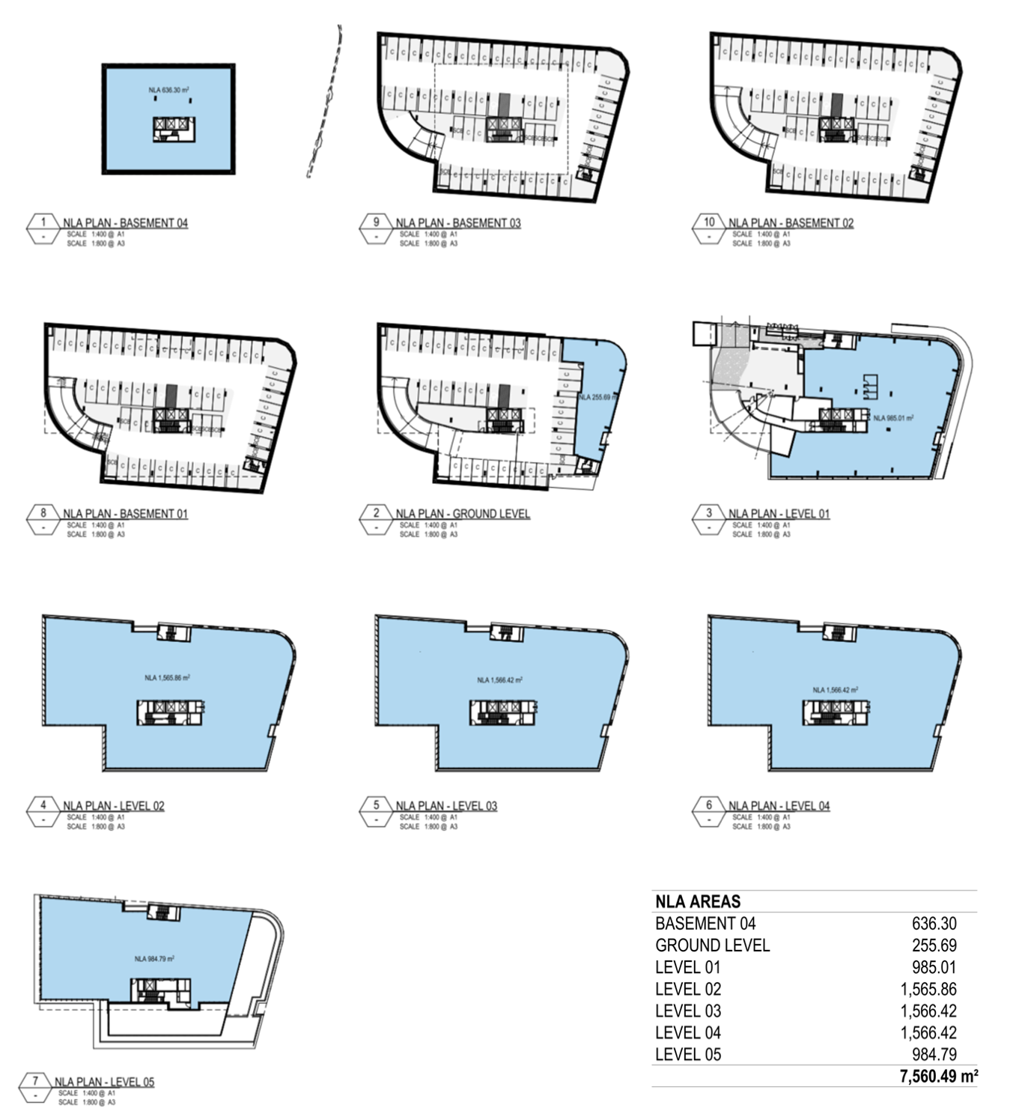

|  |  |
| --- | --- |
| Figure 8 (left) | AHH Flor plan. Net Lettable Areas are highlighted in blue. See *Att C – Architectural Drawings* |
| Table 2 (right) | Net Lettable Area (NLA) per floor |

**Parking Facilities:** The AHH boasts 197 carparks, spanning from the ground level to basement levels 01-03, ensuring convenient access for patients, visitors, and staff.

**Building Height and Structure:** With a total height of 28.4m (excluding basement levels and including the roof), the building stands as a prominent landmark in the area. The design maximises natural light and creates a modern aesthetic, featuring floor-to-ceiling glass external walls (Figure 9).

**Outdoor Amenities:** The health hub includes amenities that enhance patient experience and staff well-being. An outdoor terrace facing east, spanning 141.9m2, provides a tranquil space for relaxation and reflection. Additionally, a garden area on level 05 facing south covers 163.72m2, offering a peaceful retreat amidst the urban landscape.

North Elevation

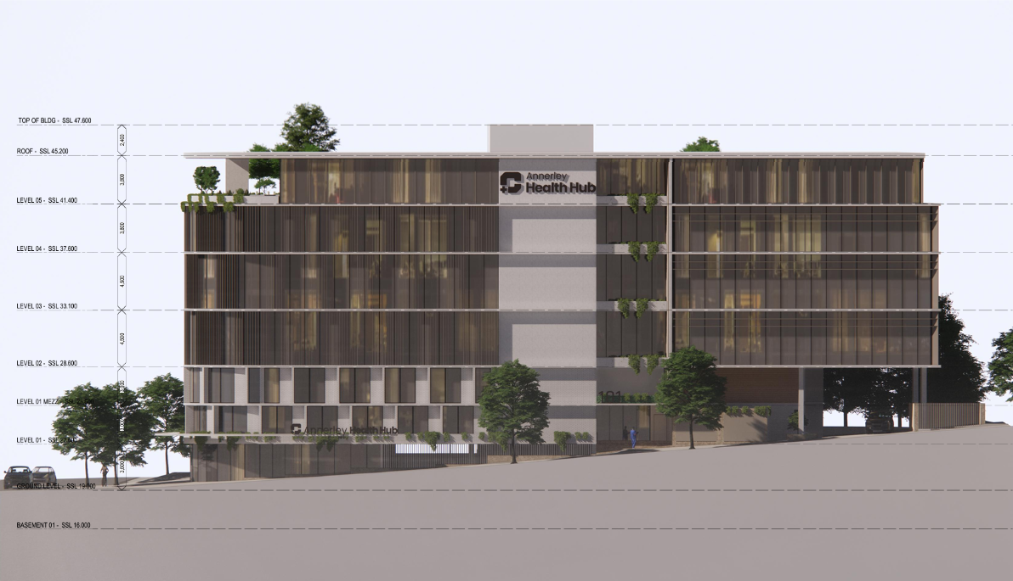

|  |  |
| --- | --- |
| Figure 9 | North elevation renderings of AHH project |

## Sustainability

In line with our commitment to sustainability, the healthcare facility will incorporate various features and initiatives to promote environmental responsibility and resource conservation:

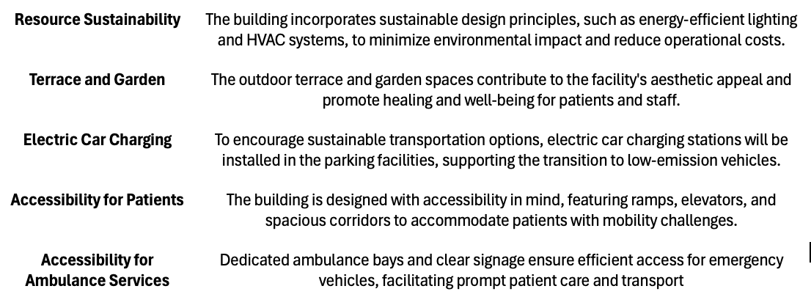

# Strategic Positioning | SWOT Analysis

**Strengths**

* **Government Subsidies:** $3.5 billion in bulk billing incentives for general practitioners; triple the incentive from the previous budget, provides certainty over the income streams for lessee’s and lessors for the health hub (Richardson, 2023).
* **Marriage Value with the PA Hospital:** The health hub's proximity to the PA hospital will create value and organic demand.

**Weaknesses**

* **Market Competition:** The presence of existing health clinics and competition from nearby hospitals, such as Greenslopes Private Hospital, may pose challenges in capturing market share and establishing the AHH as a preferred healthcare destination.
* **Noise and Regulatory Compliance:** Requirements for noise mitigation measures and regulatory approvals may pose challenges during the development phase, adding complexity and potentially delaying the project timeline.

**Opportunities:**

* **Growing Healthcare Sector:** Favourable market conditions, including increasing demand for healthcare properties and government funding support, present opportunities for the Annerley Health Hub to capitalise on the growing healthcare sector and attract tenants seeking modern healthcare facilities.
* **Demographic Trends:** There is potential for increased utilisation of private healthcare services among Annerley residents, as willingness to spend on elective health will be higher with higher median incomes associated with the area, driving demand and providing a fertile market for the health hub to serve.

**Threats:**

* **Sticky Inflation:**  Prolonged periods of inflation threaten to delay rate cuts that would precede expenditure increases in the economy and will also weigh on property value, meaning demand for the services the health hub provides could be subdued initially post development before the economy climbs out of the downturn (Reserve Bank of Australia, 2024).
* **Labour shortage:** A skilled healthcare worker shortage could affect lessees' ability to fulfil obligations (Richardson, 2023). This threatens tenants' ability to maintain occupancy and increases the health hub's vacancy rates.

An extended SWOT analysis can be found in appendix B.

# Development Timeline

This construction timeline is contingent on a start date of July 1st, 2024 (FY25) and assumes that development approvals have been granted. The timeline includes a 12-month warranty period to cover repairs or unscheduled maintenance within 12 months of building handover. It is assumed that pre-construction approvals and relevant assessments for traffic, noise, stormwater, and protected matters have been completed and approved before the commencement of the development timeline outlined below.

**Sections A and B** were estimated based on general hospital construction timelines from Rawlinson’s 2024 Australian Handbook, utilising lenient timeframes to account for unforeseen circumstances such as potential delays in tendering for selecting a builder contractor and pre-lease agreements with tenants.

**Sections C and D** were estimated based on staging reports of comparable development projects from BESIXWatpac, including the St George Hospital Stage 3 Redevelopment and Hornsby Ku-ring-gai Hospital Stage 2 Redevelopment (NSW Government, 2024). These assumptions were critical in estimating the property value and land estimation costs in the evaluation analyses of this report.

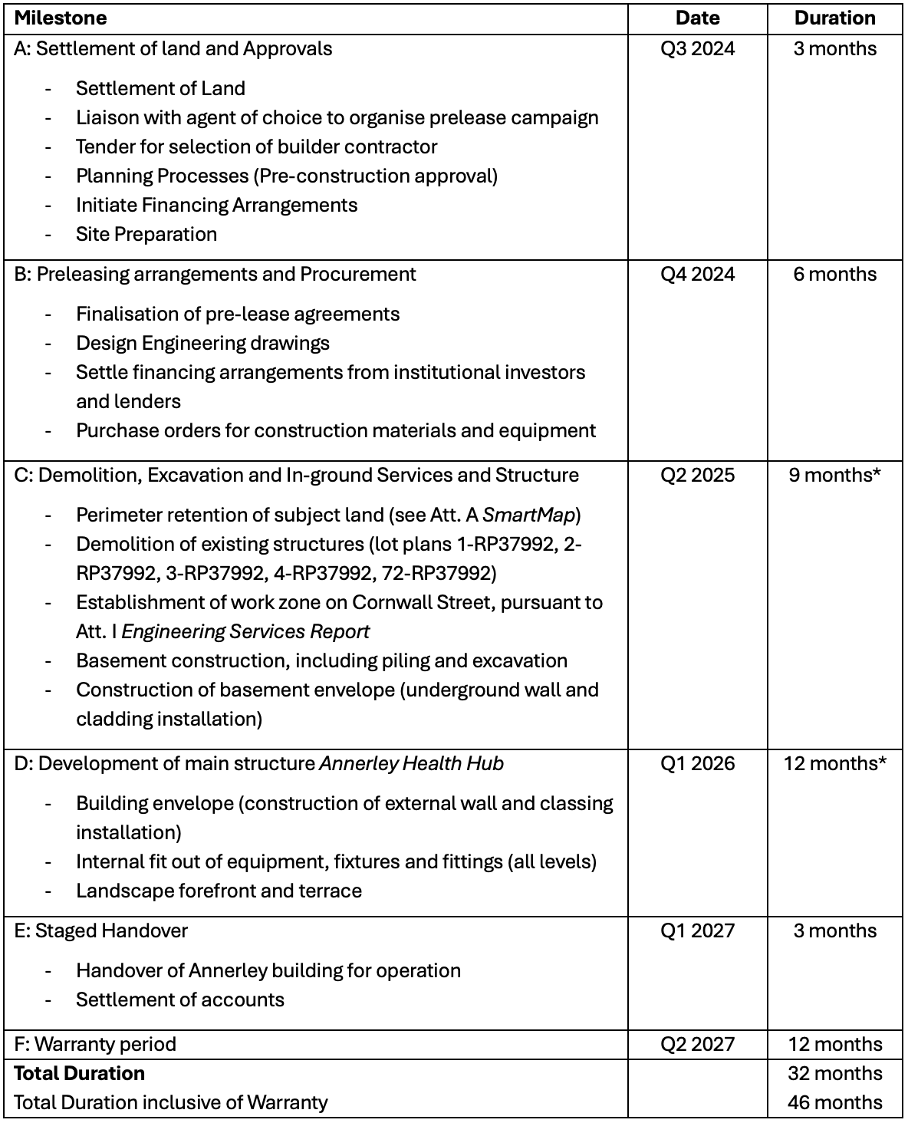

# Investment Analysis

## Construction Cost Estimation

The construction cost estimate for the project sourced from Rawlinson’s Handbook (2024) was calculated by dispersing the costs across the 2025 and 2026 financial periods (as outlined in sections C and D of the construction timeline). These costs were adjusted for CPI inflation and further refined by breaking down the desired Gross Building Area (**GBA**) by the defined pre-leased tenancy mix and attributing their respective construction costs. This approach ensured that the total construction costs were accurately distributed over the two-year period while accounting for inflation and the specific requirements of the development.

|  |  |
| --- | --- |
| Table 3 | Construction Cost Composition |

## Demolition Cost Estimation

The Annerley development site necessitates demolishing four buildings and an adjacent carpark before construction. While assuming the relevant development approvals, the certainty of the building's demolition was verified by referencing the relevant search codes in the heritage registry (Queensland Government, n.d.).

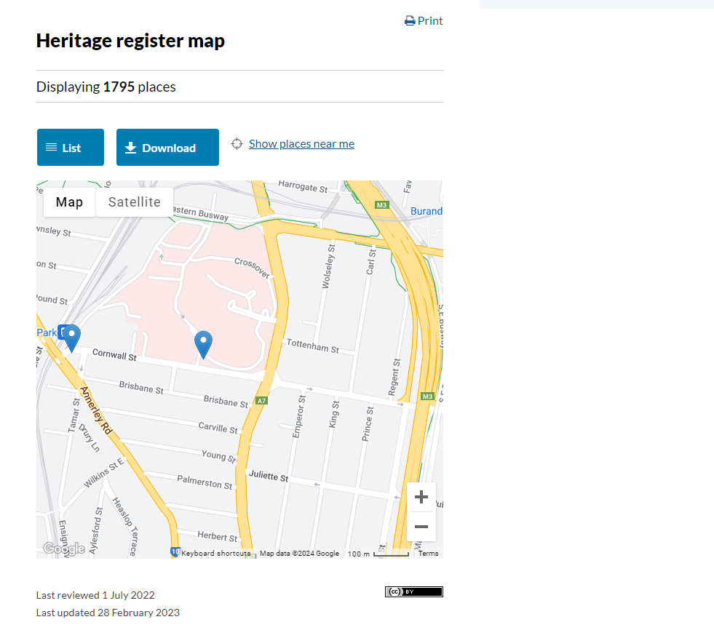

|  |  |
| --- | --- |
| Figure 10 | Heritage listing map of surrounding areas to AHH project. Source: (Queensland Government, n.d.) |

## Asbestos

Recent house sales observation determined that dwellings on 97 Cornwell, 99 Cornwell, and 279 Ipswich Road Street contain asbestos floor and wall sheeting, which must be considered in the demolition costs (*Realestate.com.au*, n.d.). Removal and disposal of asbestos material can significantly increase demolition costs, with online quotes indicating additional costs of $40 per square meter (Pro House Demolitions Brisbane, 2023) (see Tables 4 and 5). Additional removal costs for the carpark over property lines 1-RP37922, 2-RP37922, and 3-RP37922 were also factored into the final demolition costs, with costs provided below by Rawlinsons (outlined in Table 4 and Figure 11 below).



|  |  |
| --- | --- |
| Table 4 | Demolition and Disposal Costs assumptions |

|  |  |
| --- | --- |
| Figure 11 | Composition of Demolition costs across parcel RP37992 |

## Lease Agreements and Tenancy Terms

Utilising market rents from the *RP Core Logic* database, appropriate market rents were isolated and inflation adjusted as comparator benchmarks for the identified tenancy mix. The gross market rents were retrieved by analysing lease contracts of the same tenant types within a 10km radius of the development project. Further details and computations can be found in Appendix A. Corresponding fit-out contributions and leasing incentives were also incorporated into the rent schedule, as outlined in Appendix A.



|  |  |
| --- | --- |
| Table 5 | Tenancy mix |

AHH's tenancy strategy targets healthcare tenants with attractive incentives and competitive face-value rents in the project's later stages. The strategic location near the Princess Alexandra Hospital and CBD enhances the appeal to healthcare providers. The project offers semi-funded (50%) speculative fitouts to drive demand and secure pre-commitments upon completion in addition to a five-year continued lease option. Appendix A provides fit-out estimates for each tenancy type, with Specialist Health Services, Cafe, and Pharmacy (on levels four and five and ground level, respectively) budgeted for cold-shell fitouts, reflecting higher face rentals, while other services receive warm shell fit-out contributions.

## Land Value Estimation

The land value of the AHH was estimated using a weighted blended average of two methodologies: the extrapolated market value and the hypothetical development net land value. The extrapolated market value method calculated the estimated price per square meter by identifying 5 local historical transactions between 2023 and 2024 on land surrounding the AHH. The extrapolated market value was weighted higher in the blended land value at 60%, as it was determined to be a balancing metric of the land’s fair value, utilising numerous recent sales in the area, which has a high probability of exemplifying similar land costs (Tables 6 and 7).



|  |  |
| --- | --- |
| Table 6 | Hypothetical Valuation Model |



|  |  |
| --- | --- |
| Table 7 | Composition of Demolition costs across parcel RP37992 |

# Fund Structure

The liability structures of Australian real estate investment trusts (AREITs) are bifurcated. Some AREITs opt for secured debt and equity, while others choose more complex legal structures.

Incorporating mezzanine finance into the fund structure development project is not advised for this project. Mezzanine finance typically includes debt covenants that restrict LWH's ability to refinance its loan easily in the future, hindering LWH's flexibility in managing its financial obligations in changing market conditions. In addition, the payment obligations assigned to mezzanine finance investors, which take precedence over the issuance of returns to equity investors, increase the stock's risk profile compared to comparable AREITs that do not employ this financing strategy.

If LWH faces unfavourable terms in raising capital for large-scale projects, a dispositional joint venture (DJV) could be a strategic alternative. If raising the required capital through new funds, existing cash balances or project size is impractical, a dispositional joint venture (DJV) with an existing unlisted healthcare fund (e.g., Nexus Property Fund) could be considered (Freybote et al., 2014). A DJV would allow Live Well Healthcare (LWH) REIT to maintain partial property ownership, providing an alternative to selling it outright (Freybote et al., 2014). This approach could be beneficial if the REIT lacks financing capabilities or the managers lack the competencies to understand the nuances of healthcare property finance. However, the subsequent development schedule assumes the fund is large enough and maintaining full property ownership is feasible. In such a case, a simple capital structure model involving a private single lender will be pursued, providing approximately $61.4M to fund the project's construction. The development and term loans will be securitised on the AHH project and maintained in a separate trust (Figure 12).

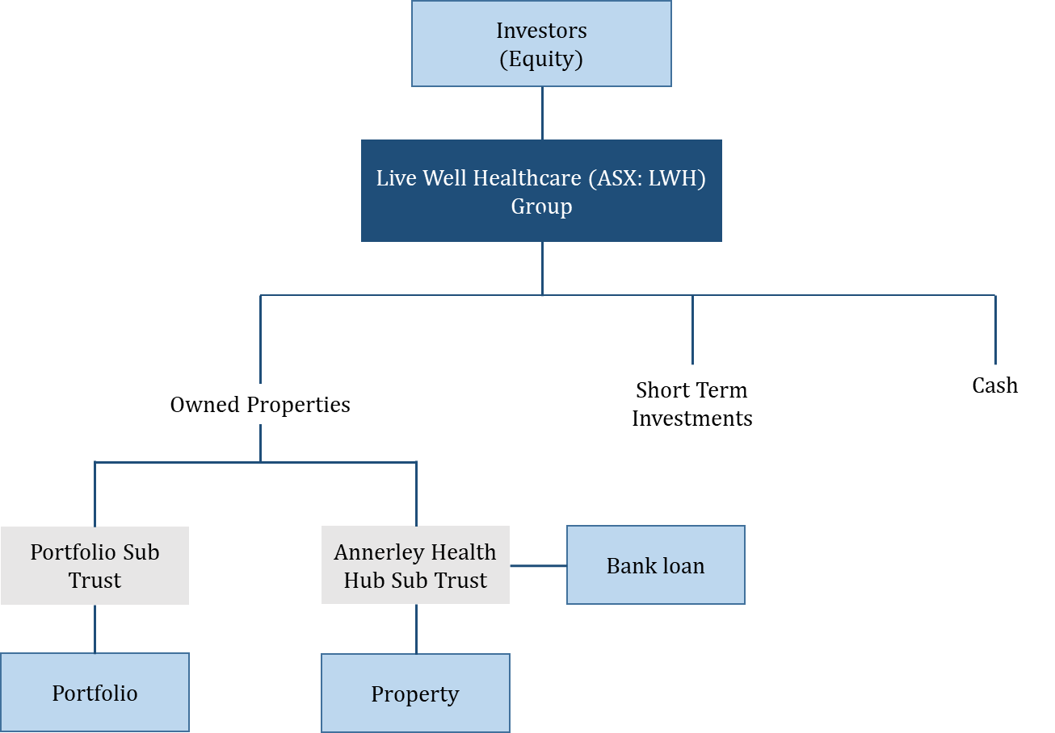

|  |  |
| --- | --- |
| Figure 12 | AHH project fund structure |

## Capital Structure

Pershica Associates posits that various debt and equity-based strategies may be considered when undertaking this project. In the current macroeconomic environment, the cost of debt can be considered within a reasonable margin of safety owing to the defensiveness of the cashflows and the identified beta associated with healthcare properties. The strategy for identifying a favourable capital structure prioritises profit maximisation while adhering to the LVR covenants set by listed A-REITs.

AHH funding should employ little or no debt to finance themselves; there are no obvious tax advantages to debt given REITs do not pay corporate taxes, plus, there are deadweight costs of financial distress (Brown & Riddiough, 2003). Market timing predicts that a high price to net asset value will increase the probability of issuing equity in the public market and thus be associated with lower debt ratios (Harrison et al., 2011).

Ultimately, the capital structure of the fund will depend on the risk appetite of Live Well Healthcare, with leverage being associated with market-wide risk aversion (Harrison et al., 2011). Comparable listed property funds HealthCo Healthcare and Wellness (ASX: HCW) and RAM Essential Services Property Fund (ASX: REP) maintain target leverage in the range of 30-40%, whilst Centuria Healthcare property fund maintains a safe margin below their debt covenant LTV margin of 55% (Centuria Property Group, 2023).

|  |  |
| --- | --- |
| Figure 13 | LTV gearing of comparable A-REITs |

Using the weighted average of comparable healthcare REITs, a target LTV of 32.92% was determined, and a 7% contingency bucket has been reserved for each phase of construction to address uncertainties (see Appendix C). The project's debt financing currently adopts a conservative approach to meet debt covenants and maintain investor confidence. Notably, the defensive, high-yield nature and conservative gearing enables the potential to utilise less conventional debt and fund structuring options. Specifically, the primary consideration for funding should be profit maximisation with the capacity for flexibility. The project's minimal identified risks, as determined through SWOT and risk analysis, make this a viable option. Additionally, in a high-interest rate environment where investors seek defensive cashflow projects, such as the AHH, attracting investment at a premium is possible.

## Debt Schedule

It is recommended to open a line of credit at the beginning of the construction phase of the project location (Section C of the *Construction Timeline)* and drawdown at each phase of the construction timeline to meet a target of 32.92% LTV. At the end of the 22-month construction phase, the debt will be refinanced into a secured 15-year loan contract to pay off over the asset's holding period, allowing LWH to maintain a conservative approach in inflationary pressures in an uncertain economic outlook (Figure 14).

|  |  |
| --- | --- |
| Figure 14 | Debt repayment schedule, AHH project |

# Viability of Project

## Financial Metrics

Pershica has strenuously evaluated and stress-tested the proposed development through DCF and Hypothetical Valuation models, yielding key financial metrics including NPV, IRR, Cash on Cash ROE and ROTDC. The unlevered approach utilised a discount rate of 7.53% and a capitalisation rate of 5.15% a comparable weighted average (Appendix A), reflecting market risk expectations adjusted by comparable five-year betas of healthcare-listed property trusts.

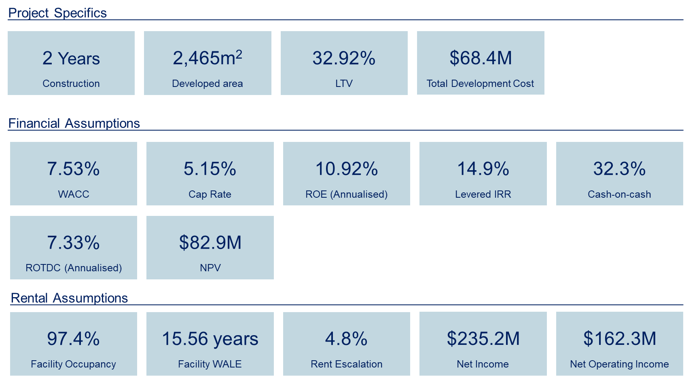

The Annerley Health Hub project is highly profitable, development is estimated to take 2 years to complete on a lenient assumption accounting for potential construction delays due to unexpected events. With a relatively low LTV of 32.92% and a cost of $68.4m relative to the net income of $235.2 million, the project's profitability is optimistic.

AHH has also capitalised on the high demand for healthcare facilities and services, with confident assumptions on increasing rent escalations, long facility WALES, and high average occupancies of 97.4% for tenants. Given that these positive rental assumptions prevail throughout the hub's lifetime, annualised ROE is forecasted to be 10.92%, which establishes the project to be a viable and profitable investment to add to the portfolio of LWH. With a cash-on-cash return of 32.3%, the project demonstrates excellent cash flow generation relative to the equity invested. The IRR revealed a value of 14.9%, an appropriate expected return for healthcare developments, exceeding most benchmarks. Given the lower risk metrics. In this case, with a cost of debt of approximately 7.05%, Pershica can safely recommend the viability of the AHH project beating the debt servicing costs by 8%.

## Risk and Sensitivity Analysis

Although various figures utilised multiple comparator firms with a similar operation and size to AHH, minuscule differences exist, potentially causing errors within the model and leading to incorrect information. Notable figures in the excel utilising comparators to estimate figures include WALE, Beta, ROE, rent prices, capitalisation rate, and gearing ratio. Further investment risks have been identified, and mitigation strategies have been devised in Appendix C. Sensitivity analysis observed how variance in the discount and cap rate flowed through to financial metrics NPV, IRR and ROE within the model generated. They have been assessed with respect to ±1.5% of the original values obtained.











|  |  |
| --- | --- |
| Figure 15 | Sensitivity Analysis Metrics |

Notable characteristics include a robust IRR, shifting within ±0.5% of originally forecasted values. This suggests that the IRR is less sensitive to discount and cap rate changes, indicating a degree of shielding to interest rate changes. NPV and ROE are comparatively more sensitive to changes in these variables, with the maximum and minimum combinations of the two rates spanning an NPV from A$50,981,706.53 to A$141,570,684.09. Similarly, ROE spans 6.72% to 18.66%, breaching the cost of debt in the minimum range.

## Recommendation

Presenting a fortified position as a major healthcare service-providing site with a well-diversified tenancy mix across both general and specialist practices, Pershica posits LWH proceed with the AHH project. As inflationary and input pricing pressures continue to ease, Pershica posits AHH will actualise its’ significant earnings potential over the long-run horizon. The project's strong financial metrics, strategic location, and defensive market positioning serve to compound value in Live Well Healthcare REIT's portfolio.

The financial projections for the AHH underscore its long-run viability. The sensitivity analysis reveals a mean NPV of $82.86 million, with an IRR of 14.91% and a ROE of 10.92%. The project demonstrates resilience across varying discount and cap rate scenarios, highlighting its robustness in different economic conditions.

Pershica Associates and Cornerstone Group are confident that the AHH will set a new benchmark in healthcare real estate, providing exceptional value to investors, tenants, and the broader community. This development embodies a vision of integrated, sustainable healthcare that meets the needs of today while anticipating the demands of tomorrow.

# Appendix A: Valuation Model

Model Assumptions



























Development Schedule



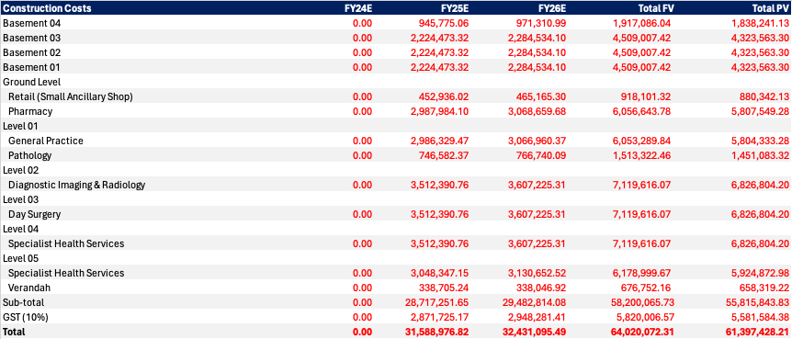



Rent Schedule



Expense Schedule



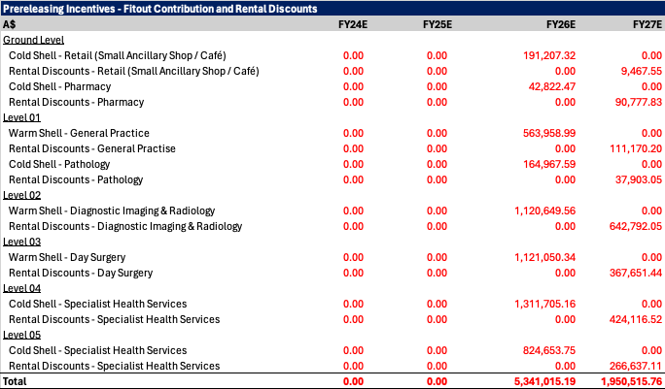

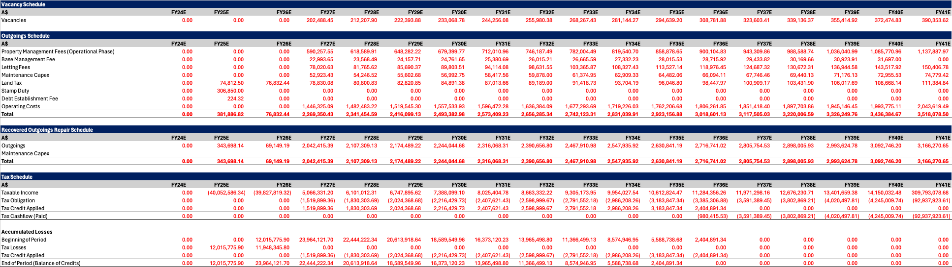

Debt & Equity Schedule





DCF





Hypothetical Development Valuation – Blended Approach



Financial Statements





Sensitivity Analysis











# Appendix B: SWOT Analysis

**Strengths**

* **Government Support:** The 2023-24 Federal budget includes a $6.1 billion investment to strengthen Medicare: a key demand driver, and $3.5 billion in bulk billing incentives for general practitioners. These factors help provide certainty over the income streams for both lessee’s and lessors for the health hub (Richardson, 2023).
* **Strategic Location:** The Annerley Health Hub is easily accessible via frontage to two major roads (Ipswich Road and Cornwall St), and proximity to two major public transport interchanges. Furthermore, the location is situated within the Princess Alexandra Hospital precinct, allowing Annerley Health Hub to benefit from its proximity to a major healthcare facility by creating an opportunity for ‘marriage value’. The health hub provides both complimentary and overlapping services to the PA hospital, meaning opportunities for synergy and value creation for the health hub are possible.
* **Diverse Service Offering:** With plans for a 6-storey building catering to various allied health services, including general practice, diagnostic imaging, pharmacy, pathology, radiology, and day surgery, the hub offers a comprehensive range of healthcare services, attracting a broad client base.
* **Development Potential:** Surrounding developments and approved redevelopment projects indicate growth potential for the Annerley area, contributing to the long-term viability and value of the health hub.

**Weaknesses**

* **Market Competition:** Presence of existing health clinics and competition from nearby hospitals, such as Greenslopes Private Hospital, may pose challenges in capturing market share and establishing the Annerley Health Hub as a preferred healthcare destination.
* **Noise and Regulatory Compliance:** Requirements for noise mitigation measures and regulatory approvals may pose challenges during the development phase, adding complexity and potentially delaying the project timeline.
* **Location development characteristics**: The development area is right up to two major roads. This means construction will impede traffic conditions surrounding the site throughout development.
* **Parking Limitations:** The proposed parking lot size of 200 spaces may be insufficient to accommodate the needs of patients and staff. Given the proposed parking lot was well below the TAPS regulations for number of spaces for an establishment for the size of the health hub, meaning there could be persistent capacity issues post-development, potentially leading to congestion and inconvenience.

**Opportunities:**

* **Growing Healthcare Sector:** Favourable market conditions, including increasing demand for healthcare properties and government funding support, present opportunities for the Annerley Health Hub to capitalize on the growing healthcare sector and attract tenants seeking modern healthcare facilities.
* **Demographic Trends:** With a younger population compared to the Queensland average and higher median household incomes, there is potential for increased utilisation of private healthcare services among Annerley residents, as willingness to spend on elective health will be higher, driving demand and providing a fertile market for the health hub to serve.
* **Collaboration and Partnerships:** The Annerley Health Hub can explore collaboration opportunities with local healthcare providers, research institutions, and community organisations to enhance its service offerings and differentiate itself in the market.

**Threats:**

* **Economic Uncertainty:** Despite signs of economic recovery, lingering effects of the COVID-19 pandemic and fluctuations in economic conditions could impact consumer spending and investment decisions, affecting the demand for healthcare services and property.
* **Inflation:**  Prolonged periods of inflation threaten to delay rate cuts that would precede expenditure increases in the economy, meaning demand for the services the health hub provides could be subdued initially post development before the economy climbs out of the downturn (Reserve Bank of Australia, 2024).
* **Labour shortage:** Skilled healthcare worker shortage could affect lessee ability to fulfil obligations (Richardson, 2023). This threatens the ability for tenants to maintain occupancy and increase vacancy rates of the health hub.
* **Regulatory Changes:** Changes in healthcare regulations, reimbursement policies, or government funding allocations may introduce compliance challenges or affect the financial viability of healthcare facilities, potentially impacting the Annerley Health Hub's operations.
* **Political issues:** The project has already faced backlash from political party members which may affect consumer sentiment surrounding the project, which may impede acceptance and initial use of the health hub (MacMahon, 2023)
* **Technological Disruption:** Rapid advancements in healthcare technology and telemedicine could disrupt traditional healthcare delivery models, posing a threat to the demand for physical healthcare facilities like the Annerley Health Hub if not adequately integrated or adapted to technological innovations.
* **Exchange rate exposure:** On the suppliers side many allied health clinics; as is the Annerley Health Hub source, medical equipment from wholesalers who source their inventory internationally, exposing allied health clinics to exchange rate fluctuations.

# Appendix C: Risk Identification & Mitigation

Risk identification & mitigation analyses the impact and likelihood of risks associated with the development. A risk matrix has been conducted to visually represent each risk, with the table below providing guidance on the criteria utilised in assessing in risk.

|  |  |  |  |  |  |  |  |
| --- | --- | --- | --- | --- | --- | --- | --- |
| Likelihood | Consequences | | | | | | |
|  | **Insignificant**  Risk is easily mitigated by normal day to day process | **Minor** | **Moderate** | **Major** | **Catastrophic** | | |
| **Certain**  >90% chance | High | High | | | Extreme | Extreme | Extreme |
| **Likely**  50%-90% chance | Moderate | High | | | High | Extreme | Extreme |
| **Moderate**  10%-50% chance | Low | Moderate | | | High | Extreme | Extreme |
| **Unlikely**  3%-10% chance | Low | Low | | | Moderate | High | Extreme |
| **Rare**  <3% chance | Low | Low | | | Moderate | High | High |

|  |  |  |  |  |
| --- | --- | --- | --- | --- |
| Risk | Likelihood | Consequences | Risk | Mitigant |
| Stakeholder backlash | Unlikely | Minor | Low | Ensure the community is informed and involved in the development process by providing regular updates through community websites, while confirming the constructions stays in alignment with community opinions. |
| Parking congestion | Unlikely | Minor | Low | Lack of carparking availability during high-demand periods can be mitigated by incentivising public transport or alternate parking areas designated to staff through employee benefits. |
| Budget overrun | Unlikely | Moderate | Moderate | Although unlikely given calculations conducted, budget can be lowered through lower quality alternatives or covered by imposing higher rent pricings |
| Insufficient demand | Unlikely | Moderate | Moderate | Conduct marketing strategies such as advertisements to increase customer reach and attract tenants and clients. Inelastic nature of healthcare ensures advertisements maintain usefulness regardless of economic conditions. |
| Tenancy conflicts | Unlikely | Moderate | Moderate | Screening each tenant to identify their feasibility to lease with AHH. Impose regulations and restrictions on tenants to maintain order. |
| Regulatory Amendments | Moderate | High | Moderate | Amendments to statutes may adversely affect the Health Hub, such as changes to tax regimes (interpretation of practices), could impact terminal value in the event of an exit. |
| Stakeholder conflict | Unlikely | Moderate | High | Conduct a stakeholder mapping, to analyse the needs and strength of each stakeholder. Provide clear and honest communication and present the positive aspects of investing into the project. |
| Natural Disasters | Rare | Catastrophic | High | Given Annerley’s high-location and minimal history of natural disasters, risk is minimal. |
| Interest rate fluctuations | Unlikely | Major | High | Secure debt funding through a fixed interest rate agreement or hedging strategy. |
| Lease Renewals | Likely | Major | High | Leases come up for periodic renewal, risks emerge when suitable terms cannot be negotiated. Should LWH not be able to secure recurring nor replacements tenants, rental return will be significantly impacted. Has been mitigated through considerable incentives to renew such as fit outs. |
| Construction schedule delays | Moderate | Major | Extreme | Thoroughly investigate all potential risks in delaying constructions. Ensure the construction schedule accounts for unforeseeable events and conduct contingency plannings. |

# Appendix D: Funding Literature Review

Borrowing money allows investors, whether individuals or institutions, to diversify their portfolios across more assets, thereby optimising their use of equity capital. Real estate transactions often involve heterogeneous, complex, and illiquid commercial properties (Harrison et al., 2010).

This section will explore various financing mechanisms that AREITs utilise to achieve their capital structure objectives. These mechanisms include joint ventures, mezzanine financing, crowdfunding, and public and private debt offerings (Baum, 2022). By examining these mechanisms and the factors influencing capital structure, we can gain valuable insights into the financial strategies of AREITs and their impact on the real estate market. A report by Smith C and Goodman, A highlighted that medical service base rate premiums are significantly linked to the proximity of affluent neighbourhoods (Goodman & Smith, 2021, p. 1).

The amount available for borrowing is determined by the lender's underwriting process, which considers the value of the properties in the asset pool and the borrower's credit quality and financing needs. To mitigate risk, senior debt exposure is typically limited to around 60% of the asset value at any given time (Baum, 2022) (Rowland, 2010, p65). Some lenders may reduce the maximum LVR if they consider that the property type or its features might make it difﬁcult to resell, particularly in a market downturn. For income-producing commercial properties, lenders assess the debt coverage ratio (DCR) or *interest cover*, ensuring that the net rental income exceeds the loan payments or interest (Montgomery & Martialay, 2015).

## Private (Senior) debt

In the capital structure of AREIT financing, senior debt plays a critical role by providing low-risk funding essential to many real estate transactions. Senior debt holders are granted priority over all other debt and equity holders, ensuring they are the first to be compensated in the event of a default. Consequently, senior debt often offers the lowest available interest rates (Baum, 2022).

The amount available for borrowing is determined by the lender's underwriting process, which considers the value of the properties in the asset pool and the borrower's credit quality and financing needs. To mitigate risk, senior debt exposure is typically limited to around 60% of the asset value at any given time (Baum, 2022) (Rowland, 2010, p65). Some lenders may reduce the maximum LVR if they consider that the property type or its features might make it difﬁcult to resell, particularly in a market downturn. For income-producing commercial properties, lenders also assess the debt coverage ratio (DCR) or *interest cover*, ensuring that the net rental income exceeds the loan payments or interest (Montgomery & Martialay, 2015).

## Considerations and fees

When considering financing options, borrowers must weigh the advantages and disadvantages of variable versus fixed-rate interest terms. While variable-rate financing may offer lower initial costs, it also carries the risk of interest rate increases which can occur suddenly and substantially. In Australia, borrowers typically have the option to choose between variable or fixed-rate interest terms, with fixed-rate options available for periods ranging from one to five years, and occasionally up to 10 years (Baum, 2022) (Montgomery & Martialay, 2015).

Alongside interest rates, borrowers should also consider the various fees associated with their financing arrangements. These fees may include upfront fees, unused commitment fees for revolving credit facilities, and arranger fees paid to the lead lender(s) for structuring and syndication. Additionally, some financing arrangements may include commitment fees that are paid as capital is drawn, or fees associated with delayed draw term loans, such as ticking fees. These fees are particularly relevant if there is a possibility that the borrower may secure more favourable financing terms in the future and choose not to draw on the committed capital, thus avoiding associated fees or interest payments (Montgomery & Martialay, 2015).

## Loan Length

Loan length varies depending on the type of loan. For residential investors, term loans can be up to 30 years for amortizing loans and 10 years for interest-only loans (Baum, 2022). For commercial properties, these loans are typically between three to 10 years, although rarely more than three years in recent years (Rowland, 2010). Line of credit loans, such as home equity loans secured on residential property, typically have terms of five or 10 years. Construction finance is usually repaid upon project completion and is typically for one to two years. Bridging finance, which is unsecured short-term lending, is typically for three to six months, while permanent finance is being secured (Rowland, 2010).

## Mezzanine Financing

Mezzanine financing is a form of capital employed in commercial real estate deals, offering flexibility and assuming higher risks compared to traditional bank loans (Gower, 2020) (Kim, 2021). Positioned between senior debt and equity in the capital structure, mezzanine debt is typically provided by banks or private lenders. It provides lenders with higher returns in exchange for accepting risks that senior lenders are unwilling to take (Gower, 2020). Luc Nijs, in his work "Mezzanine Financing: Tools, Applications, and Total Performance" illustrates this with an example, i.e. if a senior debt lender is willing to provide up to 75% of the financing for an acquisition or redevelopment project, a mezzanine loan would advance capital requirements between 75% to 90% of the acquisition or redevelopment costs, such that the owner-operator is required to pay 10% of the remaining cost.

Another application of mezzanine financing is through preferred equity arrangements. Here, the mezzanine lender becomes an investor in the borrower or owner, receiving a preferred return and a liquidation preference ahead of equity investors. Unlike traditional debt, preferred equity provides investors with ownership interests such as preferred stock, membership in an LLC, or partnership interests. In the event of a sale, refinance, or liquidation, preferred equity investors are paid back their principal investment before any distributions are made to equity holders, providing them with a higher level of security and priority in recouping their investment (Nijs, 2013).

## Joint ventures

Dispositional joint ventures (DJVs) are described as hybrid structures and provide AREITs a strategic option for disposing of properties in their portfolio. In a DJV, the AREIT sells a portion of its real estate assets to a financial partner, typically a financial institution, in exchange for joint venture shares and a substantial amount of cash (Freybote et al., 2013). The AREIT retains a minority interest in the joint venture and often retains management rights over the properties. Like independent firms, DJVs are governed by a board of directors, and partners receive control and cash flow rights proportional to their equity investments (Freybote et al., 2013). This structure allows AREITs to benefit from the advantages of joint ventures while maintaining some level of control and flexibility in their real estate investments (Mantecon & Song, 2013).

# Bibliography

Arena , 2023. Our portfolio [WWW Document]. Arena REIT. URL https://www.arena.com.au/our-portfolio/ (accessed 5.15.24).

ASX, n.d. ASX Investment Products - A-REITs [WWW Document]. ASX. URL https://www.asx.com.au/markets/trade-our-cash-market/asx-investment-products-directory/areits (accessed 5.15.24).

Australian Bureau of Statistics, 2021. 2021 Annerley, Census All persons QuickStats [WWW Document]. Australian Bureau of Statistics. URL https://abs.gov.au/census/find-census-data/quickstats/2021/303021052 (accessed 5.15.24).

Australian Bureau of Statistics , 2024. Australian economy grew 0.2% in the December Quarter [WWW Document]. Australian Bureau of Statistics. URL https://www.abs.gov.au/media-centre/media-releases/australian-economy-grew-02-december-quarter (accessed 5.15.24).

Australian Unity, n.d. Robina Private Hospital, Robina, QLD [WWW Document]. URL https://www.australianunity.com.au/wealth/build-your-wealth/property-funds/healthcare-property-trust/robina-private-hospital-robina-qld (accessed 5.15.24).

Australian Unity , 2024. Healthcare Property Trust - Class A Units.

Baum, A., 2022. Real estate investment: A strategic approach. Taylor & Francis.

Burke , G., 2024. A-REITs – Health Check [WWW Document]. Wilsons Advisory. URL https://www.wilsonsadvisory.com.au/news/a-reits-health-check (accessed 5.15.24).

Burnet, L., 2023. M3 property - National health market snapshot. M3 Property.

Centuria Healthcare Property Fund, 2024. Monthly fund update February 2024.

Centuria Property Group, 2023. Centuria Healthcare Property Fund [WWW Document]. Centuria. URL https://centuria.com.au/wp-content/uploads/2021/11/Centuria-Healthcare-Property-Fund-Report-November-2021-v2.pdf (accessed 5.14.24).

Consultants, R.Q.S. and C.C., 2024. Rawlinsons Australian Construction Handbook 2024. Rawlinsons.

Dexus, 2024. Dexus Convenience Retail REIT [WWW Document]. Dexus. URL https://www.dexus.com/investor-centre/listed-funds/dexus-convenience-retail-reit (accessed 5.15.24).

Dexus, n.d. Dexus Healthcare Property Fund [WWW Document]. Dexus. URL https://www.dexus.com/investor-centre/unlisted-funds-management/dexus-healthcare-property-fund (accessed 5.15.24).

ELANOR HEALTHCARE REAL ESTATE FUND [WWW Document], 2021. . Elanor Investors Group. URL https://www.elanorinvestors.com/investors/managed-fund/elanor-healthcare-real-estate-fund (accessed 5.15.24).

Filmer, I., 2024. Capitalising on hospitals: REITs’ latest investment strategy. Real Estate Business.

Freybote, J., Gyamfi-Yeboah, F., Ziobrowski, A.J., 2013. Dispositional joint ventures as REIT financing strategy. Journal of Property Research 31, 87–107. https://doi.org/10.1080/09599916.2013.790464

Gonzales, K., 2023. Retail Property Operators in Australia [WWW Document]. IBISWorld. URL https://my.ibisworld.com/au/en/industry/l6712b/at-a-glance

Goodman, A.C., Smith, B.C., 2021. Medical service quality and office rent premiums: Reputation spillovers. The Journal of Real Estate Finance and Economics 66, 680–708. https://doi.org/10.1007/s11146-021-09855-z

Gower, Dr.A., 2020. Preferred equity or mezzanine debt: What’s right for you? [WWW Document]. The Crowd Fund Real Estate Investor. URL https://gowercrowd.com/real-estate-syndication/preferred-equity-mezzanine-debt (accessed 5.14.24).

Harrison, D.M., Panasian, C.A., Seiler, M.J., 2010. Further evidence on the capital structure of reits. Real Estate Economics 39, 133–166. https://doi.org/10.1111/j.1540-6229.2010.00289.x

HealthCo Healthcare & Wellness REIT [WWW Document], 2024. . HMC Capital. URL https://www.hmccapital.com.au/our-funds/healthco-healthcare-wellness-reit/ (accessed 5.15.24).

How to Price Your Medical Room For Rent – Medical Rooms Online [WWW Document], 2021. . Medical Rooms Online. URL https://medicalroomsonline.com.au/blog/how-to-price-your-medical-room-for-rent/ (accessed 5.15.24).

Hudgins, C., 2024. US REITs underperform broader market in Q1 2024 [WWW Document]. S&P Global Market Intelligence. URL https://www.spglobal.com/marketintelligence/en/news-insights/latest-news-headlines/us-reits- underperform-broader-market-in-q1-2024-81080060 (accessed 5.15.24).

Jaswanth, D.K., 2023. Institutional Building Construction in Australia [WWW Document]. IBISWorld . URL https://my.ibisworld.com/au/en/industry/e3022/at-a-glance

Kim, J., 2021. Mezzanine Financing [WWW Document]. Wall Street Prep. URL https://www.wallstreetprep.com/knowledge/mezzanine-financing/ (accessed 5.14.24).

M3 Property, 2023. National Health Market Update - M3 Property [WWW Document]. M3 Property’. URL https://m3property.com.au/health-market-snapshot-may-2023 (accessed 5.14.24).

MacMahon, A., 2023. Proposed MID for a 6-storey medical centre on Ipswich Rd [WWW Document]. Proposed MID for a 6-storey medical centre on Ipswich Rd. URL https://www.amymacmahon.com/mid_ipswich_rd (accessed 5.15.24).

Mantecon, T., Song, K., 2013. The control and performance of joint ventures. SSRN Electronic Journal. https://doi.org/10.2139/ssrn.2307706

Montgomery, M., Martialay, E., 2015. REIT Credit Facilities—Real Estate Debt in an ERA of Capital Consolidation. The Real Estate Finance Journa 240, 5–14.

Nareit [WWW Document], n.d. . Nareit REITs. URL https://www.reit.com/what-reit/reit-sectors/health-care (accessed 5.13.24).

Nijs, L., 2013. Mezzanine financing: Tools, applications and total performance. John Wiley & Sons.

NSW Government, 2024. St George Hospital redevelopment – stage 3 [WWW Document]. Health Infrastructure NSW. URL https://www.hinfra.health.nsw.gov.au/projects/project-search/st-george-hospital-redevelopment-%E2%80%93-stage-3 (accessed 5.13.24).

Outlook [WWW Document], 2024. Reserve Bank of Australia. URL https://www.rba.gov.au/publications/smp/2024/feb/outlook.html (accessed 5.13.24).

Pro House Demolitions Brisbane, 2023. House demolition cost in Brisbane for 2024 [WWW Document]. Pro House Demolitions Brisbane. URL https://prohousedemolitionsbrisbane.com/house-demolition-cost-brisbane/ (accessed 5.14.24).

Queensland Government, n.d. Heritage register map [WWW Document]. Queensland Government. URL https://apps.des.qld.gov.au/heritage-register/map/ (accessed 5.14.24).

Queensland Government Statistician’s Office, 2024. Population estimates: State and territories [WWW Document]. Queensland Government Statistician’s Office. URL https://www.qgso.qld.gov.au/statistics/theme/population/population-estimates/state-territories#current-release-population-growth-qld (accessed 5.16.24).

Queensland Health, 2021. Car Parking Concessions.

realestate.com.au [WWW Document], n.d. URL https://www.realestate.com.au/property/99-cornwall-st-annerley-qld-4103/ (accessed 5.14.24).

Reserve Bank of Australia , 2024a. Outlook-Statement of Monetary Policy-May 2024. Canberra.

Reserve Bank of Australia , 2024b. Statement on Monetary Policy – February 2024 [WWW Document]. Reserve Bank of Australia. URL https://www.rba.gov.au/publications/smp/2024/feb/overview.html (accessed 5.15.24).

Richardson, A., 2024a. Private General Hospitals in Australia [WWW Document]. IBISWorld. URL https://my.ibisworld.com/au/en/industry/q8400/at-a-glance

Richardson, A., 2024b. Health Services in Australia [WWW Document]. IBISWord. URL https://my.ibisworld.com/au/en/industry/q8400/at-a-glance

Rowland, P., 2010. Australian property investment and financing. Thomson Reuters (Professional) Australia Pty Limited.

Schroeder, N., 2023. Real Estate Investment Trusts in Australia [WWW Document]. IBISWorld. URL https://Real Estate Investment Trusts in Australia